

CSE302: Database Systems (Section 7)
Spring 2024

Project Report

Inventory Management System with POS

https://shorturl.at/phyNa

Submitted by:

Student ID | Student Name | Contribution Percentage
2022-3-60-141 | Saleh Rafi | 25%
2022-3-60-109 | Sheikh Sarafat Hossain | 25%
2022-3-60-192 | Rijia Parveen Raya | 25%
2022-3-60-243 | Wasimul Bari Rahat | 25%

E-R Model of the Project

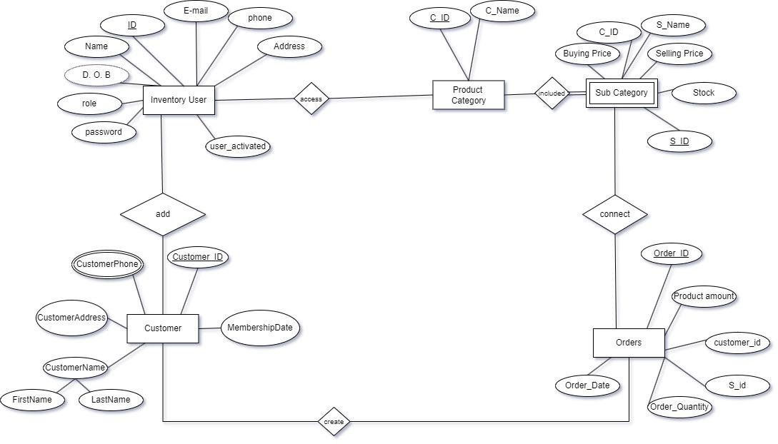

Schema Design of the Project

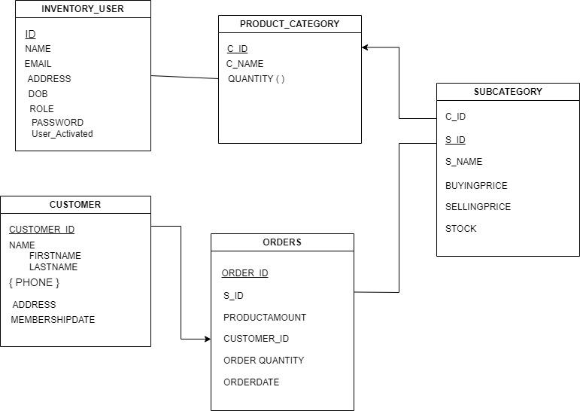

Implementation Checklist

Description | Remarks
Project ID | 204550
Workspace Name | RAFI
Workspace Email | saleh.rafi.01@gmail.com
Workspace Password | kichuekta
Authentication Type | Custom
Username and Password to Login | Username: admin, Password: 1234  Username: testing, Password: 1234
Number of Reports with Forms | 7
Number of Reports based on Queries, Aggregate Queries | 8
Extra features | We are using Sequence to generate an automatic user ID. Sometimes unique ID generation is impossible for us. It can be help to generate unique ID every time when create a new user.
Unique functionality | There are lots of unique functionality in our app. We use sequence, navigation menu, dropdown, authorization, custom authentication, nested subqueries and many things.

Reports with Forms

Report Page Number and Name | Form Page Number and Name | Table
2- Details Customer Information | 7- Customer | Customer
 |  | CustomerName
 |  | CustomerPhone
4- Non Admin Information | 7- Customer | InventoryUser
12- Debit and Credit Information | 11- Product Category  33- Order | SubCategory
 |  | Orders
14- Inventory User Details | 13- Inventory User | InventoryUser
17- Category Wise Customer | 33- Order  21- Sub Category  11- Product Category | Customer
 |  | CustomerName
 |  | CustomerPhone
22- Product Category Details | 11- Product Category | ProductCategory
23- Random Customer | 33- Order  21- Sub Category | Customer
 |  | CustomerName
 |  | CustomerPhone
26- Sub Category Details | 21- Sub Category | SubCategory
28- Customer Info | 7- Customer  9- Customer Name | Customer
 |  | CustomerName
 |  | CustomerPhone
30- details Customer | 7- Customer  9- Customer Name  10- Customer Phone | Customer
 |  | CustomerName
 |  | CustomerPhone
31- VIP Customers | 7- Customer  9- Customer Name  10- Customer Phone  33- Order | Customer
 |  | CustomerName
 |  | CustomerPhone
34- Order Details | 33- Order  7- Customer | Orders
36- Customer Order Details | 7- Customer  9- Customer Name  10- Customer Phone  33- Order | Orders
 |  | Customer
 |  | CustomerName
 |  | CustomerPhone
40- Old Customers | 33- Order  7- Customer | Customer
 |  | CustomerName
 |  | CustomerPhone
42- Product View | 21- Sub Category | ProductCategory
 |  | SubCategory

Table Name: 13- Inventory User
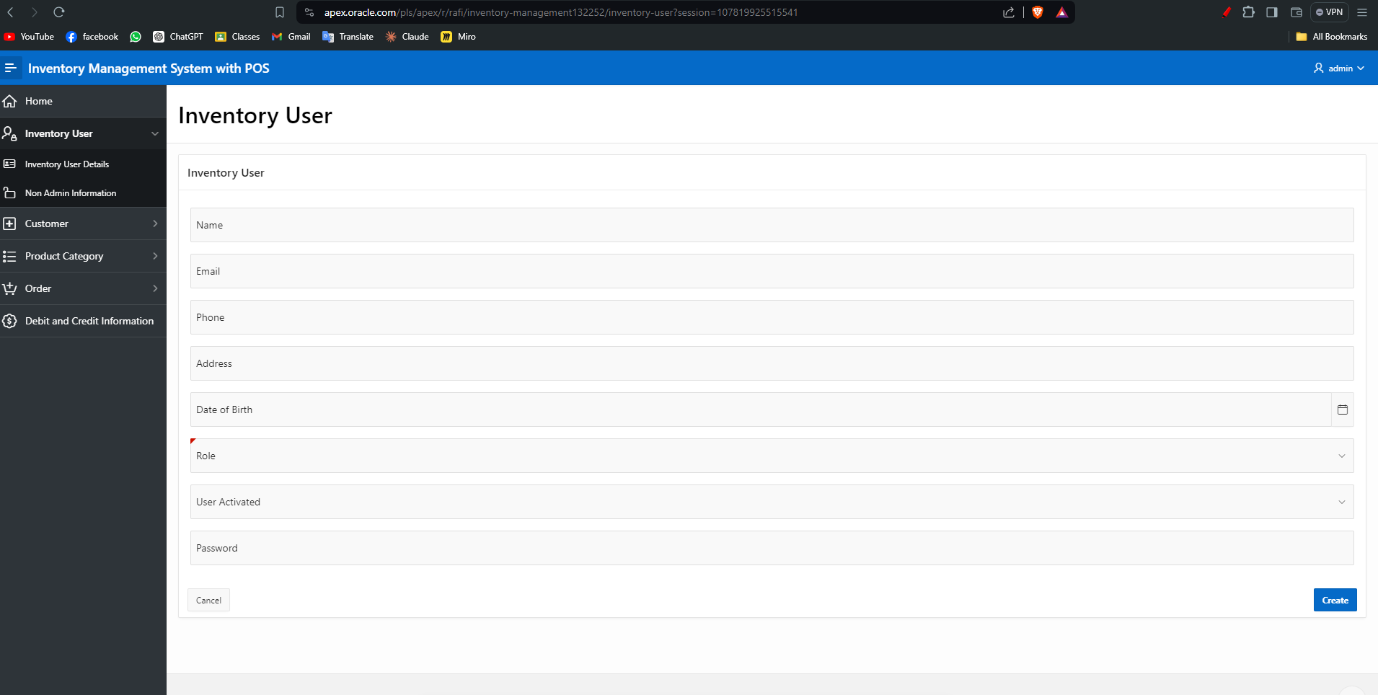

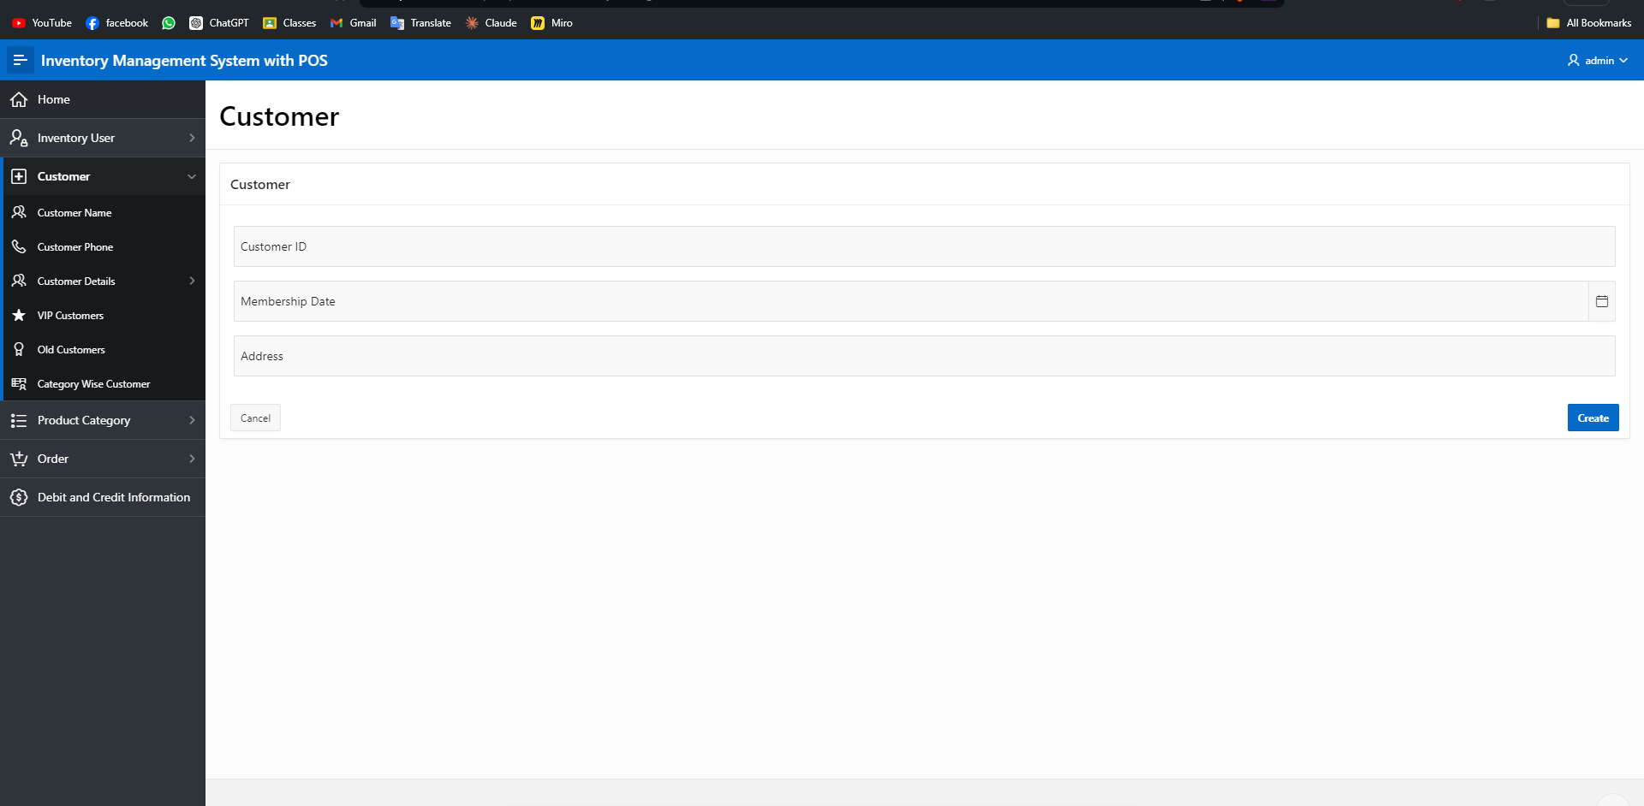
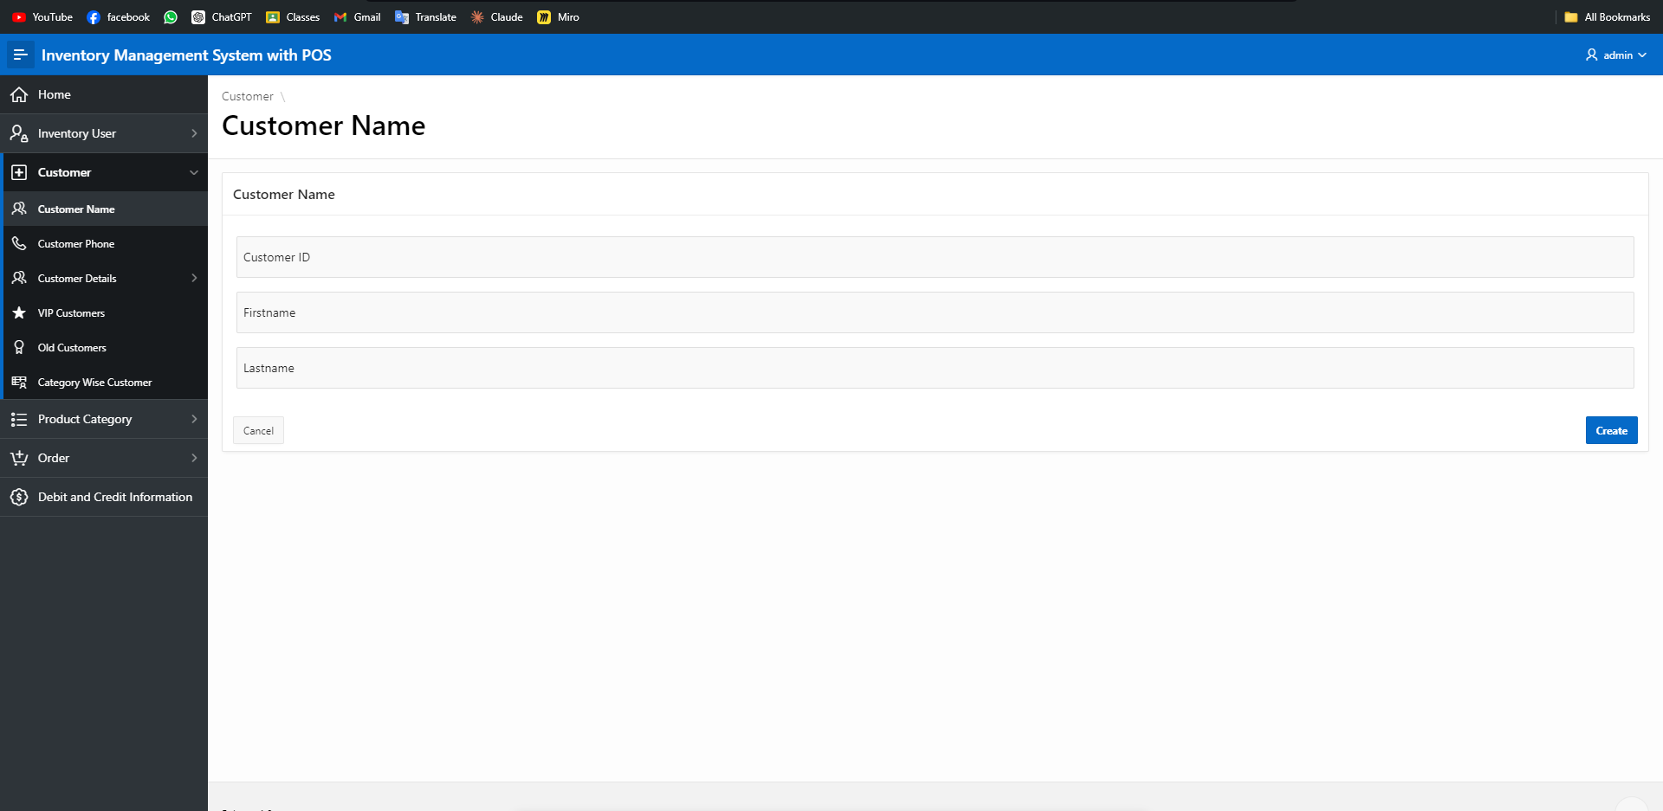
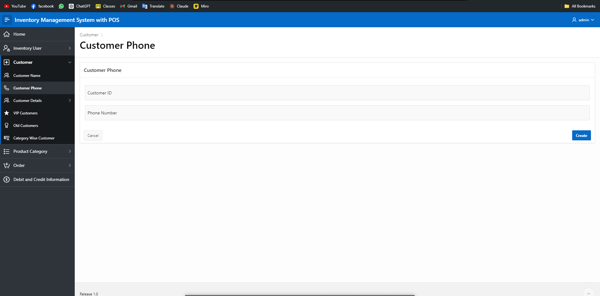

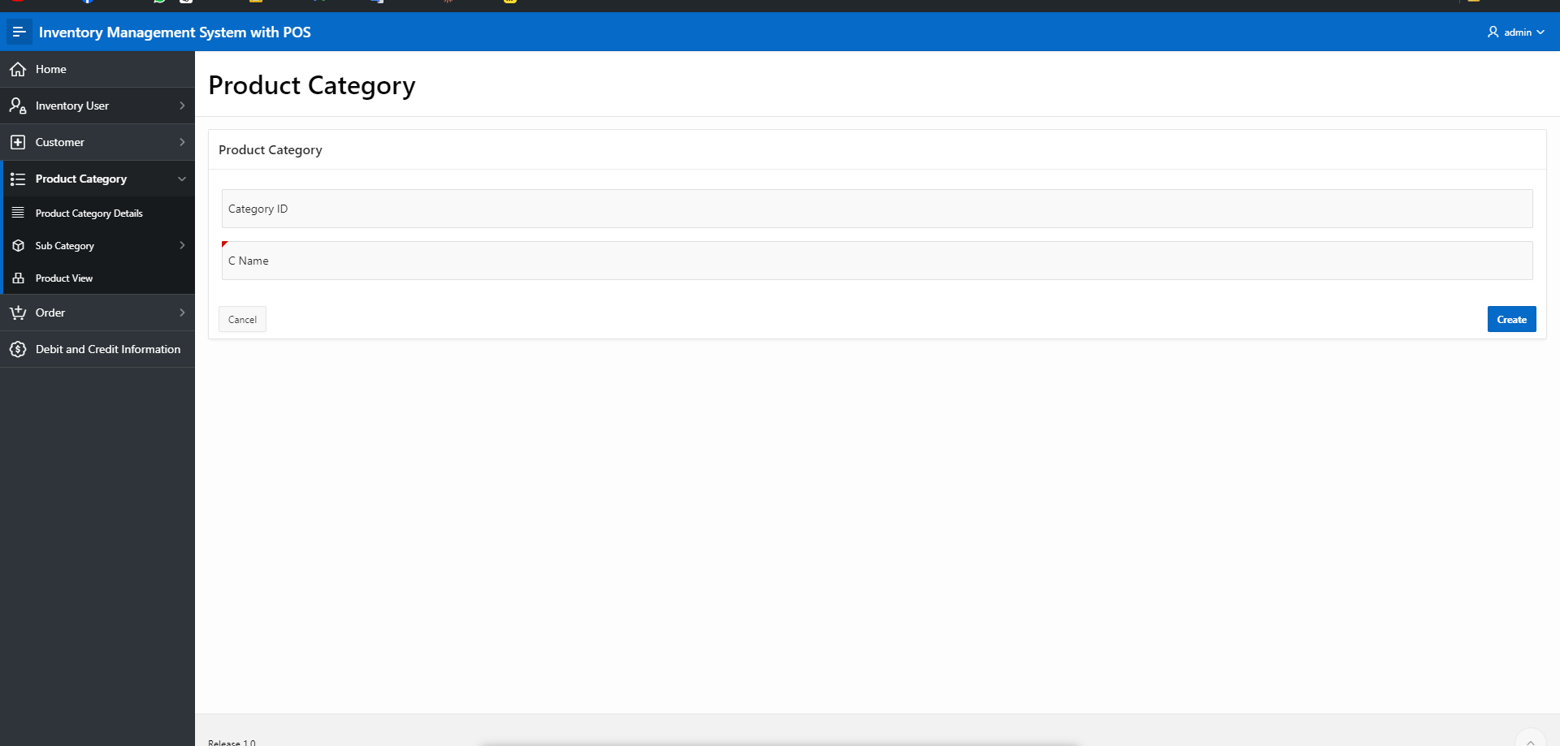

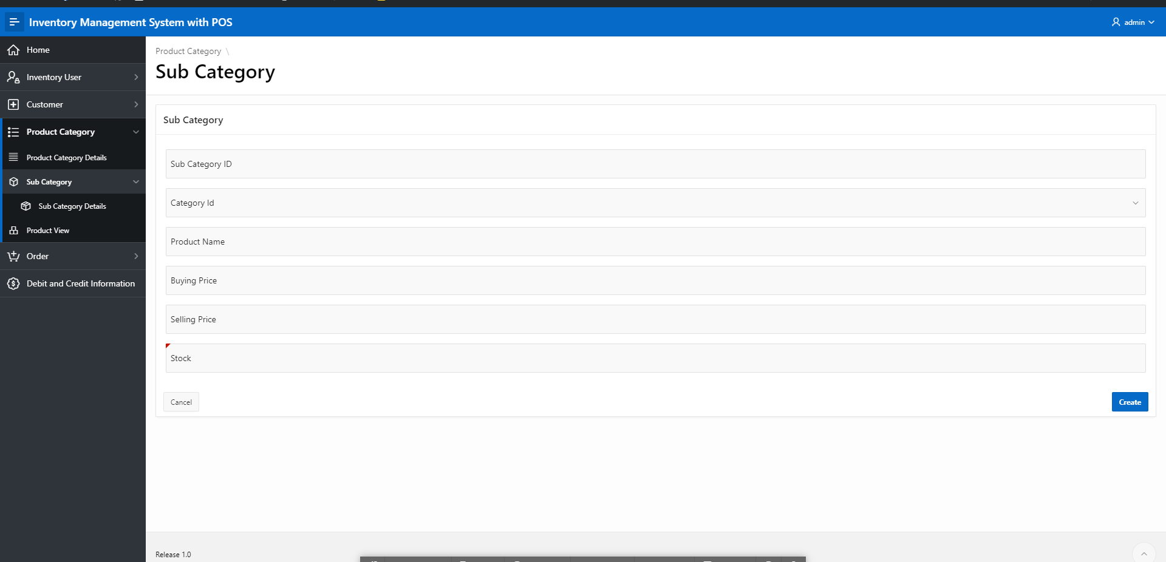

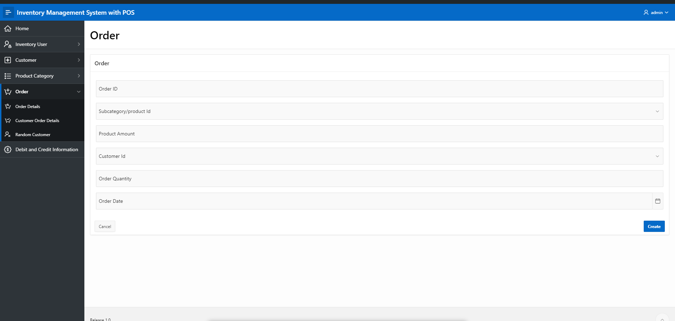

Reports based on Multi-Table and Aggregate Queries

Page Number and Name | Query Type | Report description
2- Details Customer Information | Multi-table | This table shows the details information about customer which we comes from customer, customer-Name and phone number table
4- Non Admin Information | Nested Subquery | If User is not an admin then he cannot get some confidential access. This is a nested query.
12- Debit and Credit Information | Multi-table and Aggregate | By analysis the order table this view is works it shows the revenue total cost and total profit.
14- Inventory User Details | Normal Query | This is the simple view for showing Inventory user details
17- Category Wise Customer | Multi-table | It shows the category wise customer details, for testing out default category is Grocery
22- Product Category Details | Multi-table | Product category details view shows the product category and it’s id
23- Random Customer | Multi-table | Non registered customer are treated as random customer
26- Sub Category Details | Single-table | It shows the Product List and it’s information
28- Customer Info | Multi-table | Shows full customer Information
31- VIP Customers | Multi-table and Aggregate | If customer’s purchase history is grater then average customer purchase amount then the customer starred as a VIP customer
34- Order Details | Multi-table | Its shows the order history of successfully created order
36- Customer Order Details | Multi-table | Full order information shows in this view
40- Old Customers | Multi-table | Customers who registered 1 year ago are shows in this view
42- Product View | Multi-table | It shows Information about product

Put screenshots of such types of reports. Number your figures like 6.1, 6.2 and so on.

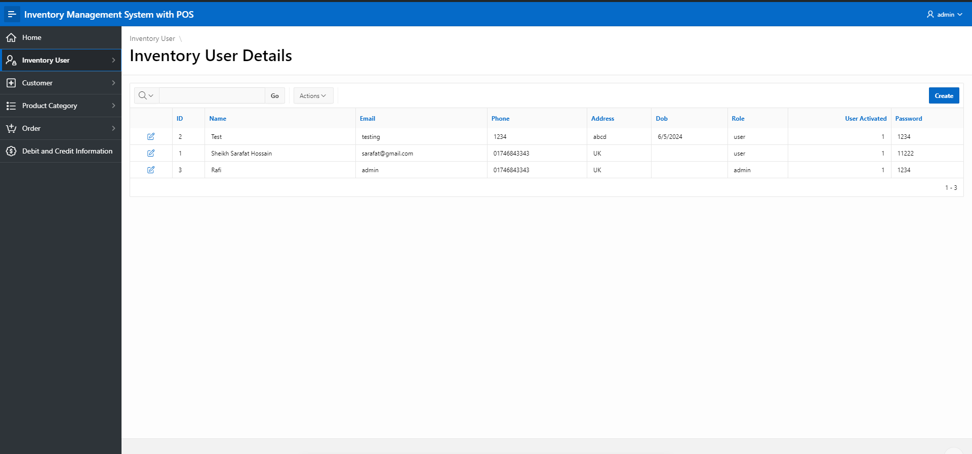
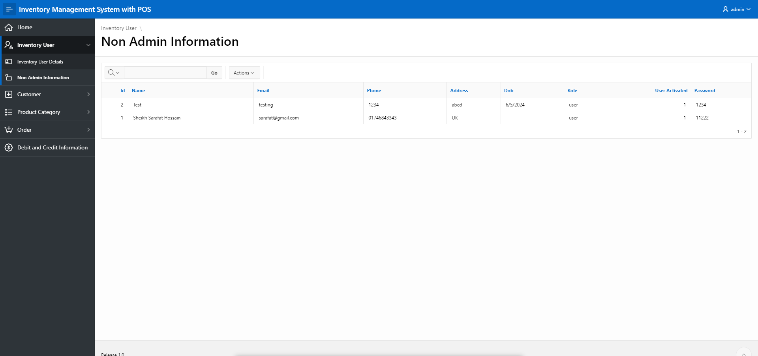
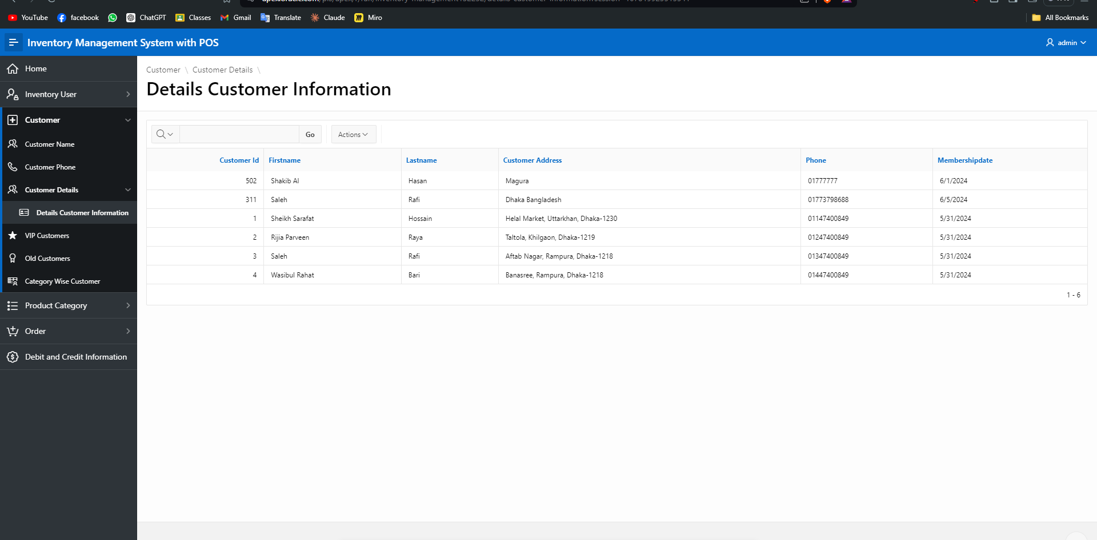

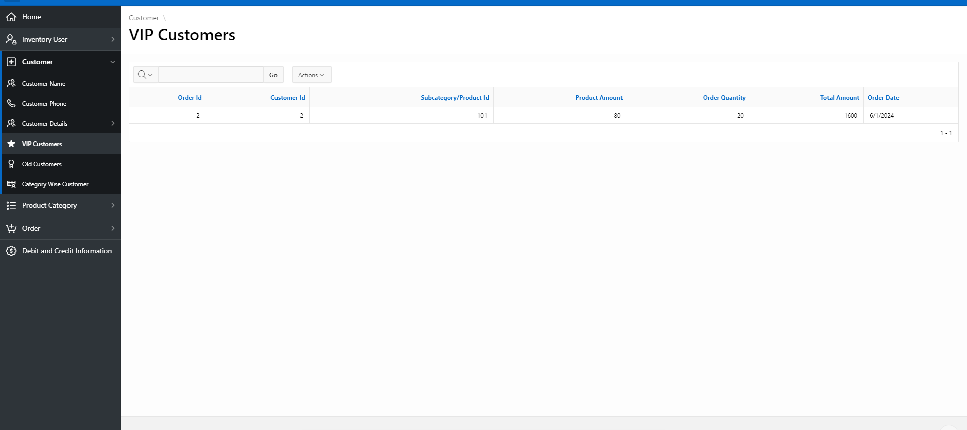
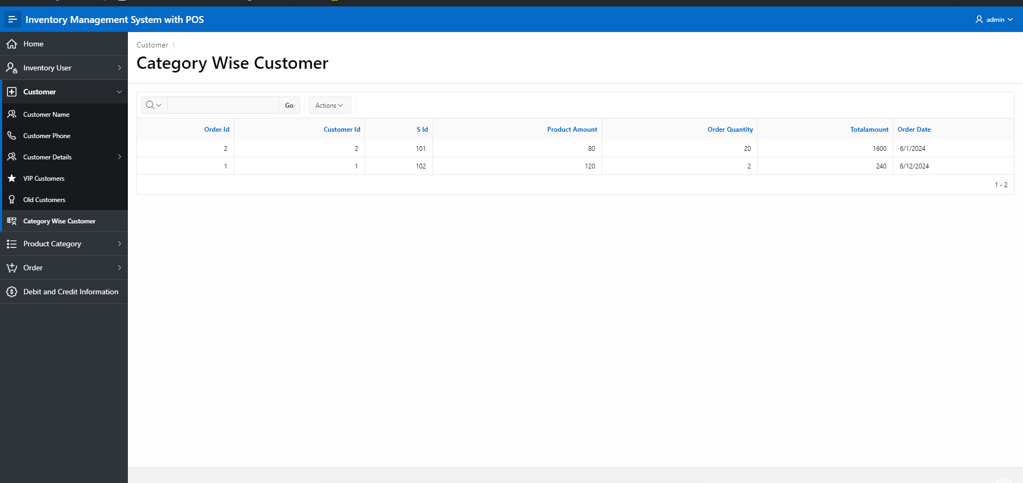
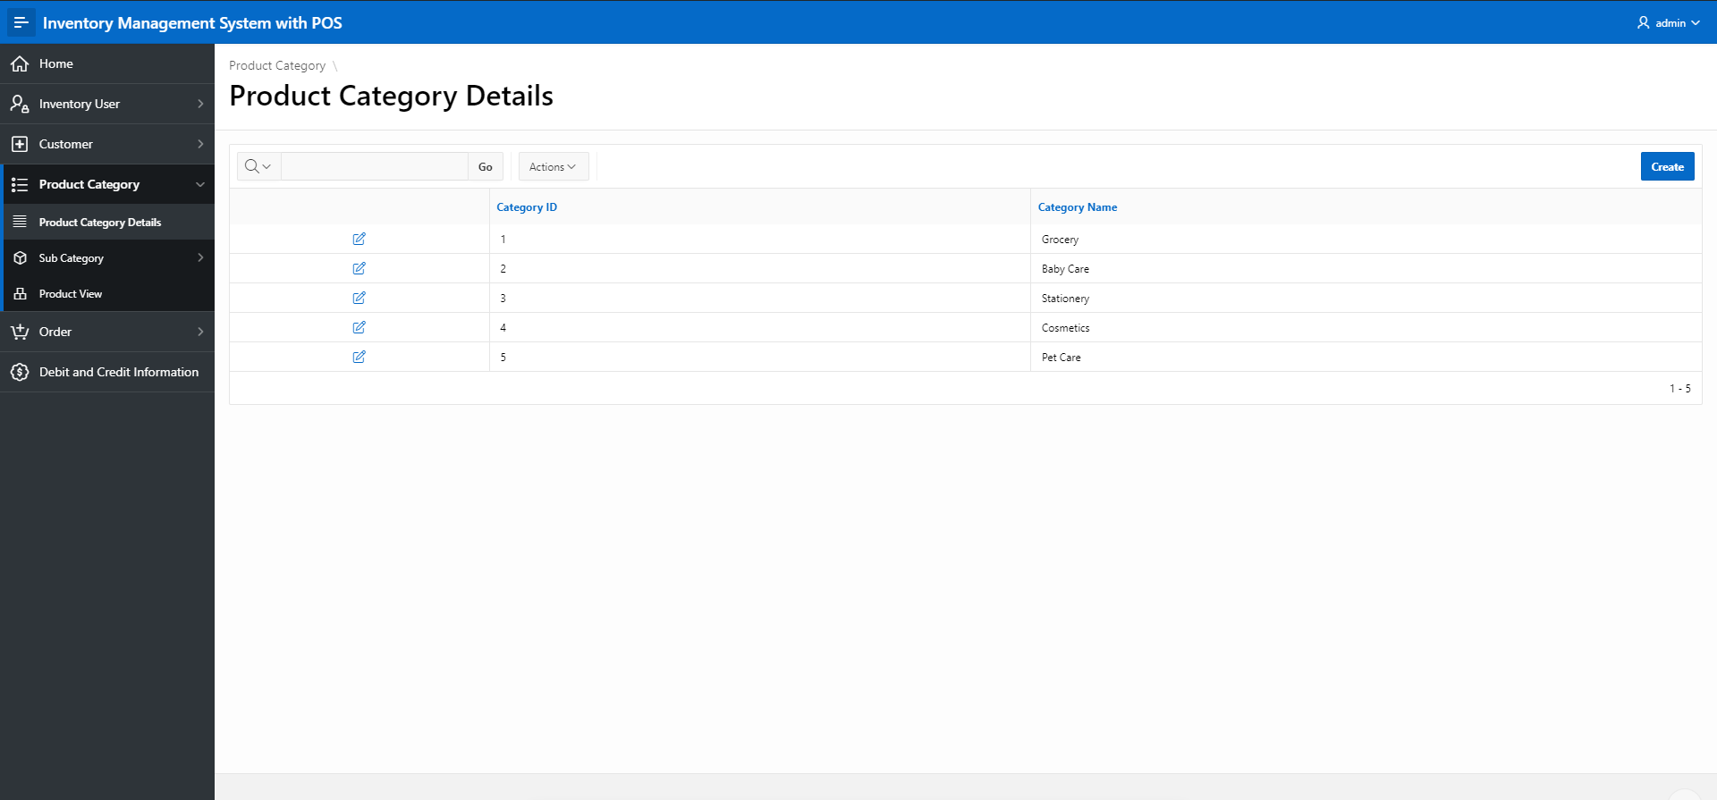
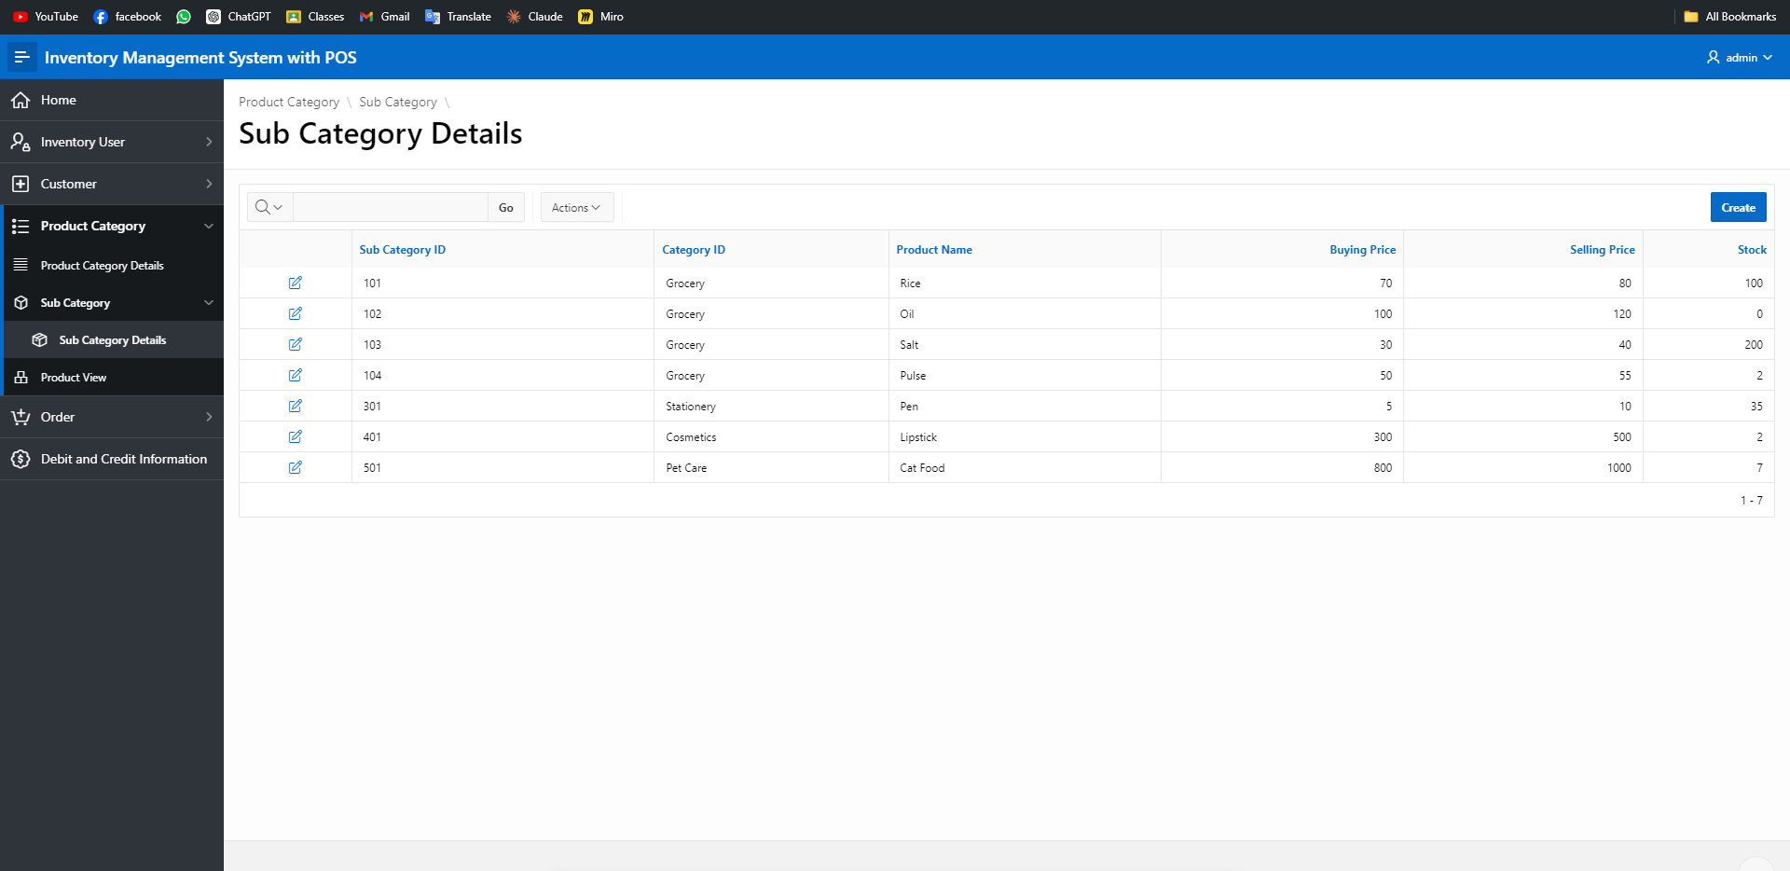
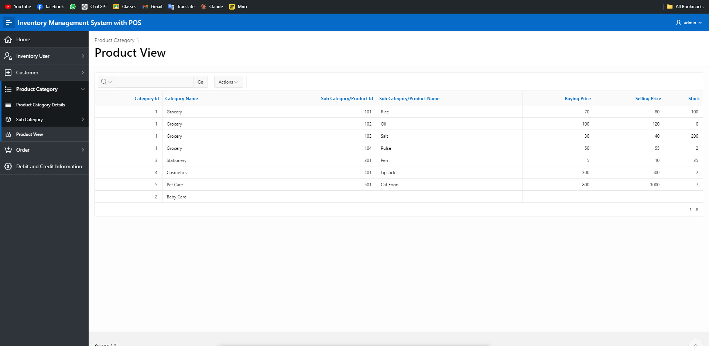
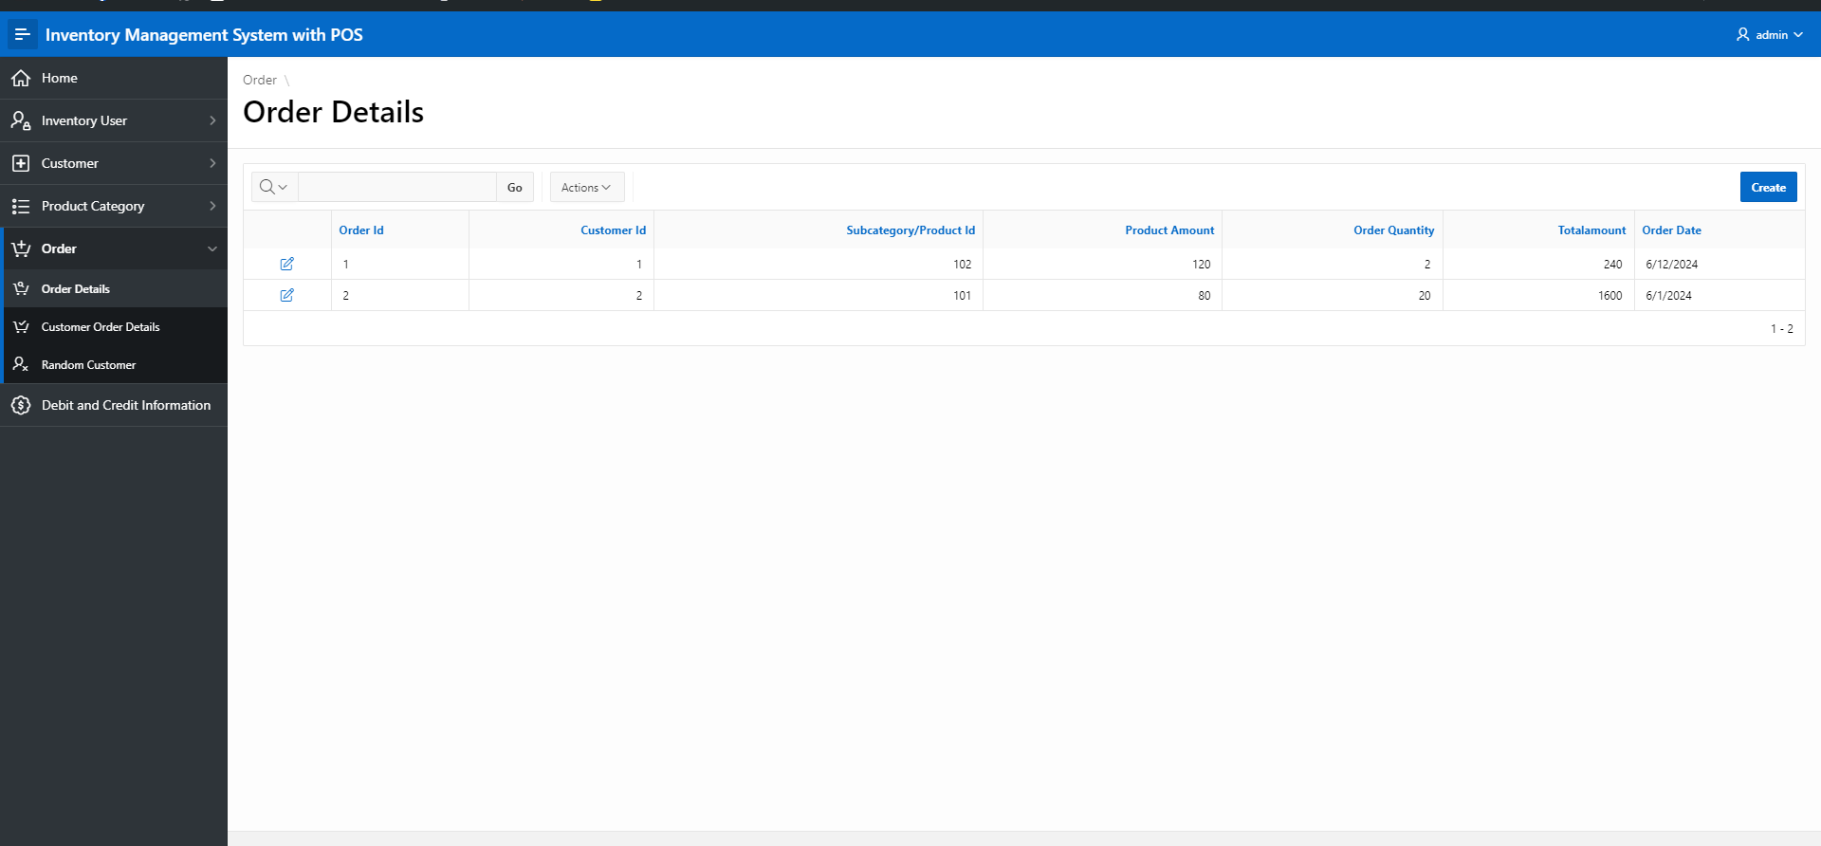

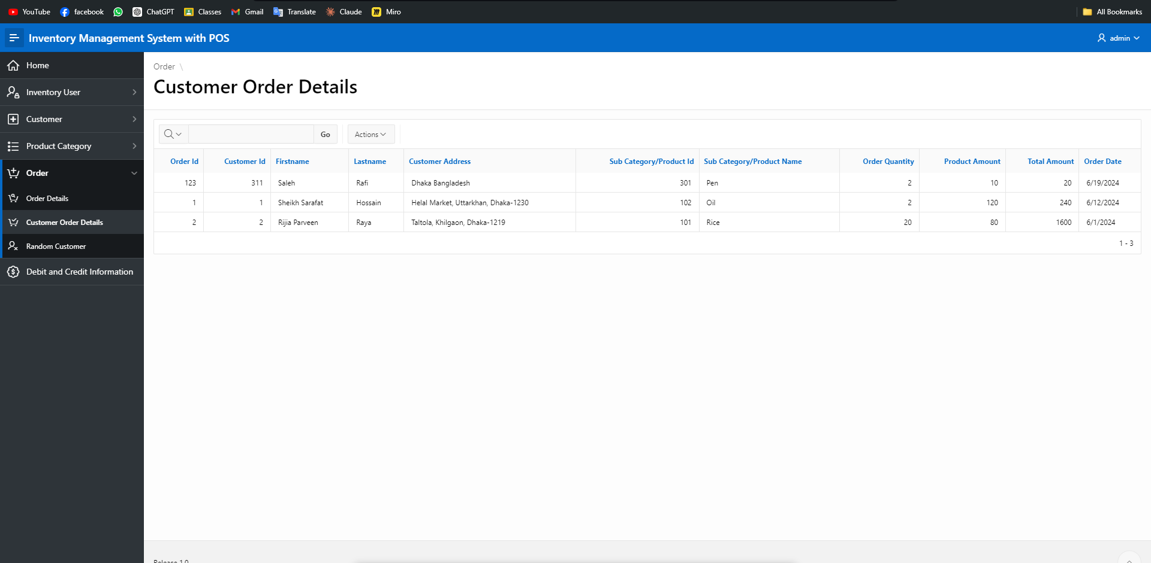
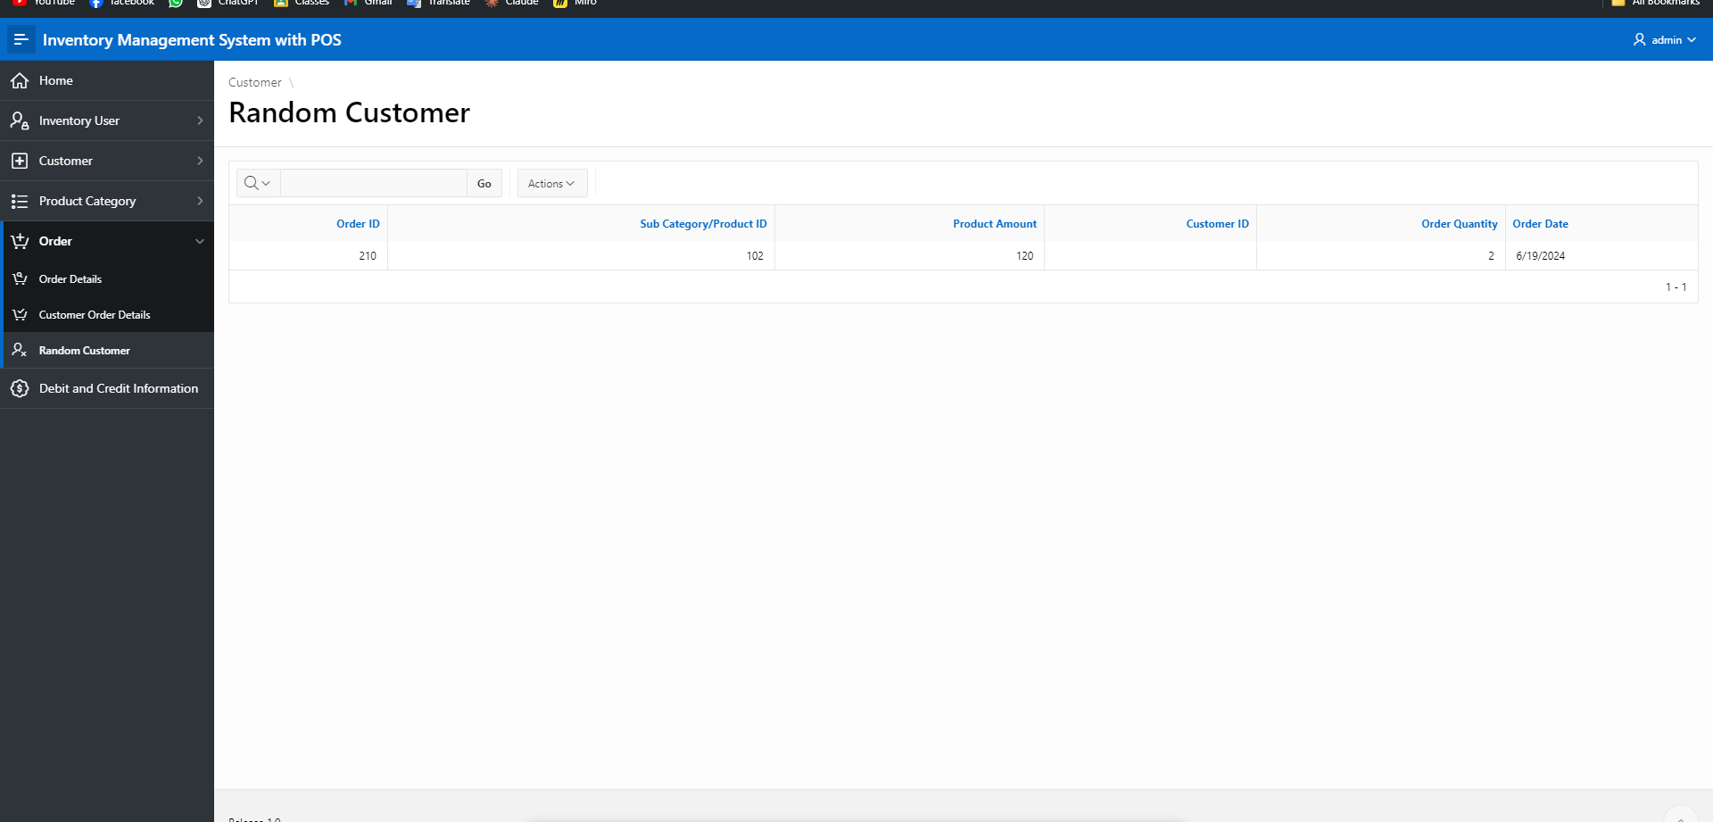
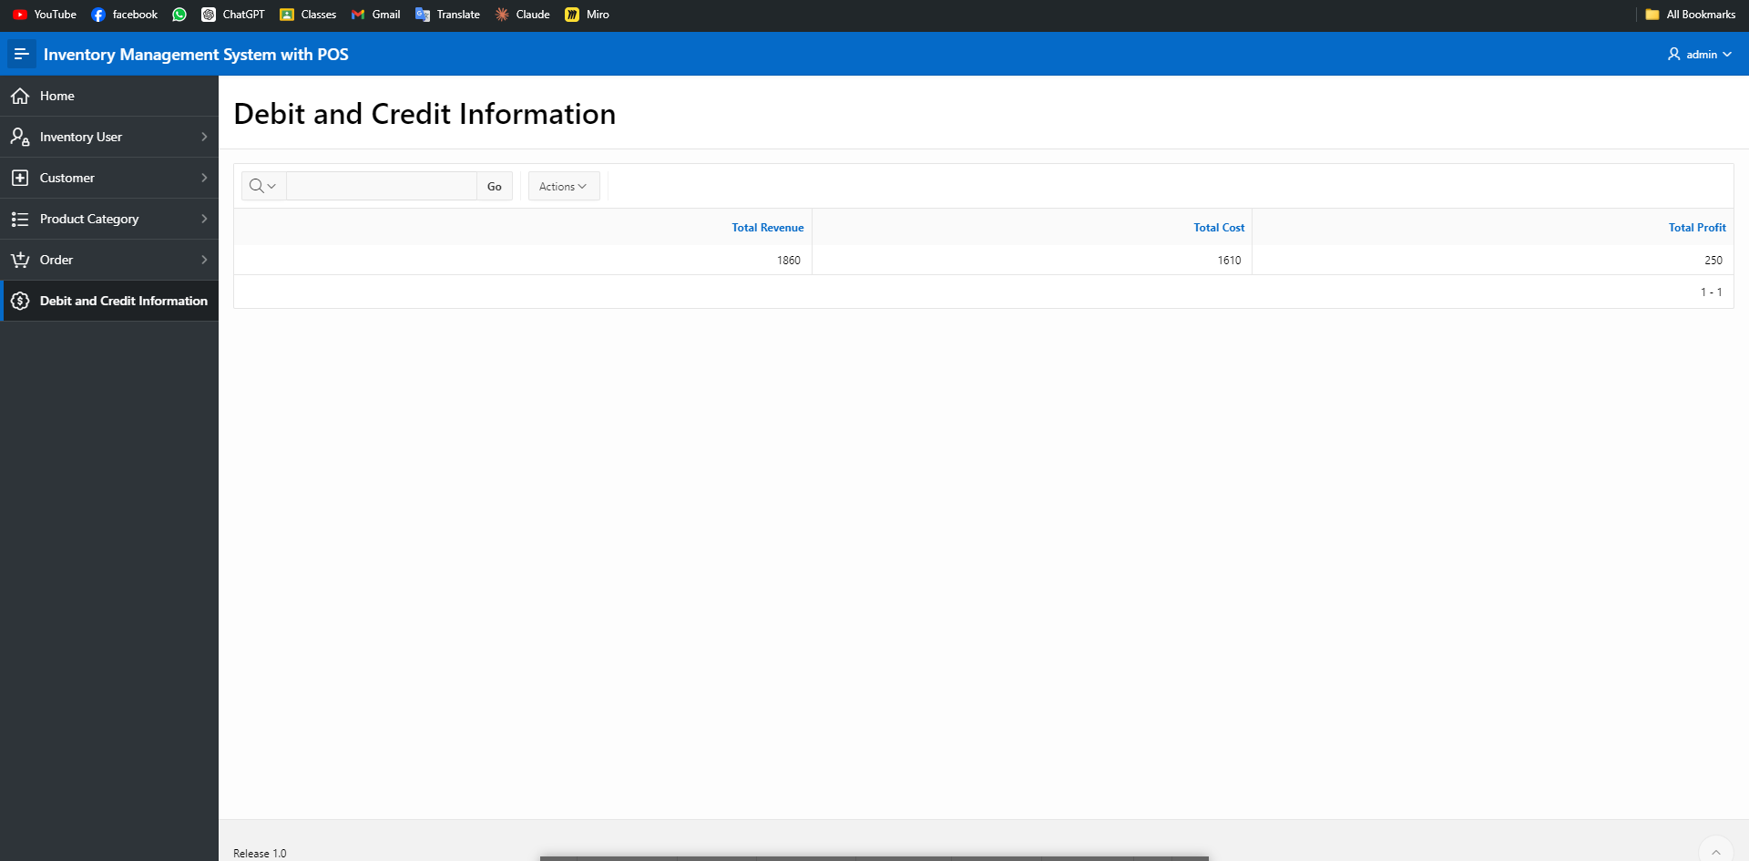

Authorization and User Role Assignment

User Role Assignment

User name | Password | Role
admin | 1234 | Admin
testing | 1234 | User
sarafat@gmail.com | 11222 | User
rafi | 1111 | Admin

Concluding Remarks

Write briefly about your experience during the project development. Write your raw feelings without any fear. I want to hear it! Thank you and Good Luck.

